October 2021
Sunday | Monday | Tuesday | Wednesday | Thursday | Friday | Saturday
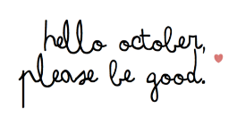 |  |  |  |  | 1  Cheese Burger with large milk $5.00  NO SOUP | 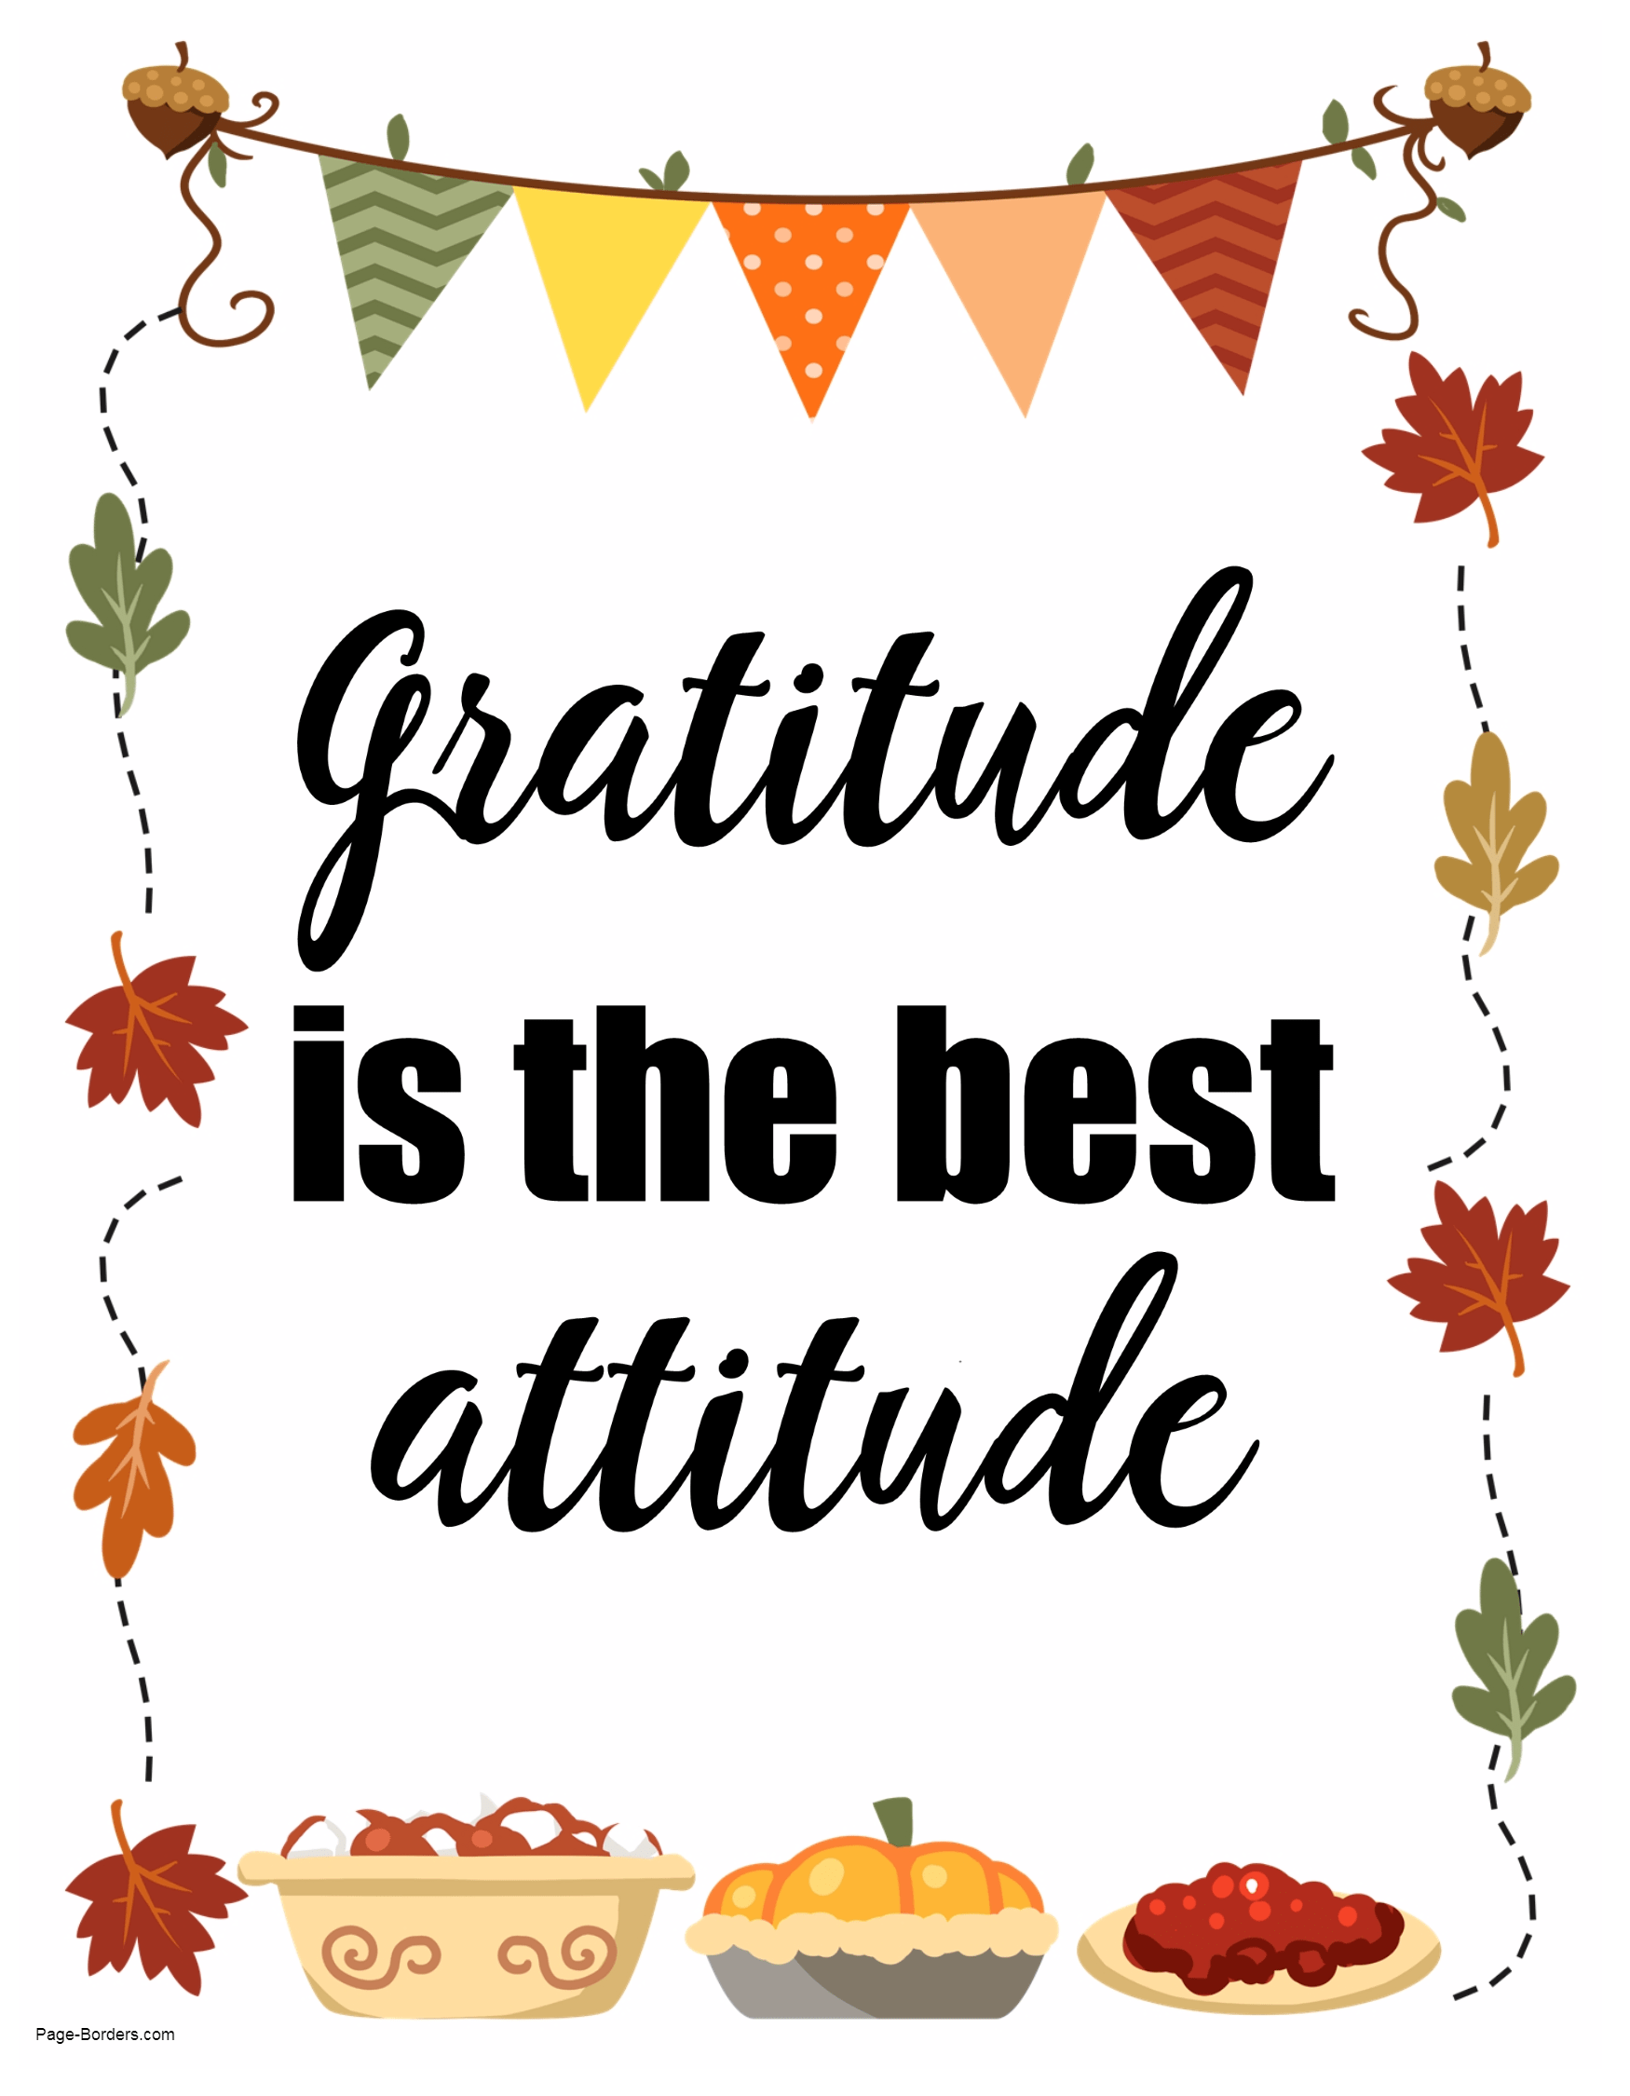
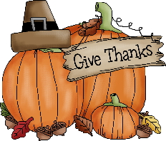 | 4  Chicken burger with chips $5.00  Mushroom soup $3.00 | 5  Sloppy Joe $5.00  Chicken noodle $3.00 | 6  2 corn dogs with a cookie $5.00  Cauliflower cheese $3 | 7  French toast with bacon $5.00  NO SOUP | 8  No school | 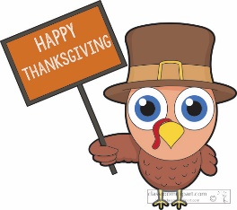
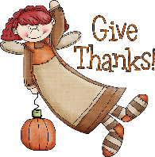 | 11  No school | 12  Rib Sub $5.00  Potato Bacon $3.00 | 13  Individual pizza $5.00  Broccoli cheese $3.00 | 14  Sheppard’s Pie $5.00  Veggie soup $3.00 | 15  Chinese plate $5.00  NO SOUP
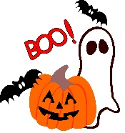 | 18  Chicken fingers and spiral fries $5.00  Cauliflower cheese $3 | 19  Meatball sub $5.00  French onion $3.00 | 20  Mac and cheese $5.00  Beef Barley soup $3.00 | 21  Chicken alfredo penne $5.00  NO SOUP | 22  Cheese Burger with large milk $5.00  NO SOUP | 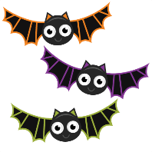
 | 25  Perogies and sausage $5.00  Chicken noodle $3.00 | 26  Grilled cheese with tomato soup $5.00  Tomato soup $3.00 | 27  Individual pizza $5.00  Beef noodle $3.00 | 28  Taco in a bag $5.00  NO SOUP | 29  Chicken bacon wrap $5.00  NO SOUP | 